AnalyzeCore plugin for IDA Pro

This is an attempt to make a plugin for IDA Pro that should assist in analyzing unix core dumps. The reason I wanted to write a IDA Pro plugin was primarily as a learning project on how to extend IDA Pro using IDC, C++, Qt.
The problem is that the remote debugger interface doesn’t support core analysis.

Login

After loading the core file I want to connect to a unix machine:

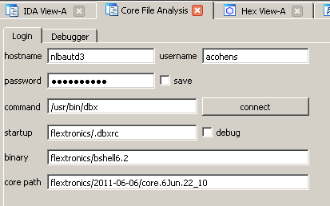

When pressing connect it will try to connect to the unix machine, using the username and the password and try to start the command (/usr/bin/dbx). The login parameters are saved in the IDB. The ‘save’ toggle after the password allows to save the password into the IDB as well..

When a connection succeeds a new cli_t will be added and the output of all the commands will be redirected to IDA’s Output Window.

the “connect” button will be used to disconnect remote connection.

debugger

The last tab contains commands to send to the debugger:

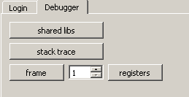

Pressing the stack trace will send a ‘where’ command to the remote debugger. One can also type commands into the command line

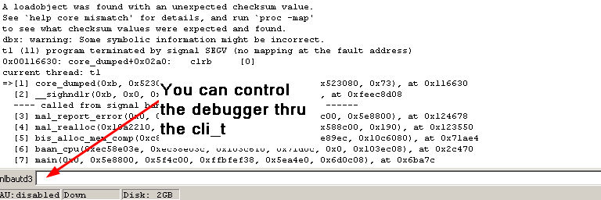

IDC functions:
The following IDC functions are added by the plugin
- telnet() start a telnet client in IDA (in cli_telnet.cpp)
- rlogin() start a rlogin client in IDA (in cli_telnet.cpp)
- rexec() start a rexec connection in IDA (in cli_telnet.cpp)

Note that you can have only one telnet, or rlogin or rexec at the same time.
The Debugger uses the rexec interface.

Disclaimer
This plugin is far from complete and it might serve as an example of how (not?) to write a plugin.

